Use Case Diagram
Figure 2 shows a Use Case Diagram of the FixIt Jo application. It illustrates the system’s functionality from the perspective of its main users, including the Customer, Technician, and Admin.

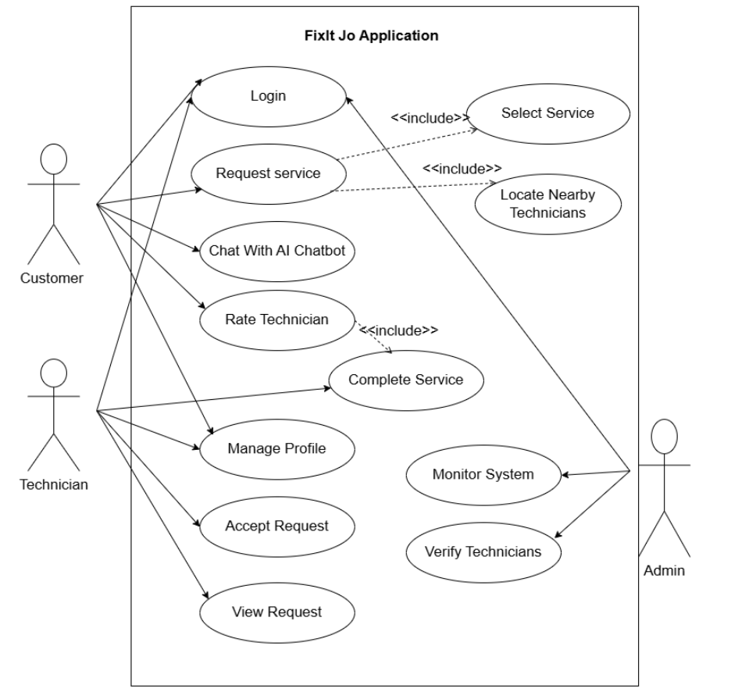
Figure 2: Use Case Diagram

